Smart Center Pivot Irrigation System
BAE 3023
Team Members: Alec Anderson and Jack Pipkin
5/7/2026

Table of Contents
Section | Title
1 | Problem Statement
2 | Design Details
2.1 | System Design Description
2.2 | Visual Documentation
2.3 | Structural Design
2.4 | Electronic Design
2.5 | Software Design
3 | Testing and Evaluation Procedures
3.1 | Subsystem Testing
3.2 | Full-System Testing
4 | Results and Discussion
4.1 | Prototype Performance
4.2 | Dashboard and Data Logging Results
4.3 | Testing Results Summary
5 | Team Collaboration
6 | Engineering Conclusions
7 | Reflection and Recommendations
8 | Bill of Materials
9 | References

Problem Statements:
- Center pivot irrigation systems rely on coordinated water delivery and tower movement.
- Failures in pumps, valves, alignment systems, and sensors can lead to water waste, crop stress, equipment damage, or downtime.
- Many systems do not provide detailed real-time monitoring or easily accessible data.
- The project addresses this by building a scaled center pivot platform that integrates water control, motion control, sensor feedback, local operator control, and data logging.
- Long-term, the data can support predictive maintenance models.

Design Details
- System Design Description
The Smart Center Pivot Irrigation System is a scaled demonstration platform that models the major control and monitoring functions of an agricultural center pivot irrigation system. The project integrates structural, electronic, and software subsystems to control water delivery, tower motion, alignment correction, local operator input, data acquisition, and remote monitoring.
The system is divided between a Raspberry Pi 5 and an Arduino Nano. The Raspberry Pi 5 acts as the supervisory controller and edge computer. It manages the OLED display, keypad interface, sensor data collection, local CSV logging, and communication with the cloud/mobile dashboard. The Arduino Nano handles time-sensitive local control, including motor drive commands, limit-switch responses, ball-valve actuation, pump-relay control, and alignment correction. This division allows the Raspberry Pi to perform higher-level data and interface tasks while the Arduino Nano maintains reliable real-time control of motion and water delivery.
Sensor inputs include soil moisture, flow rate, vibration/tilt, travel limit switches, angular alignment, and motor encoders. These inputs allow the system to monitor both irrigation conditions and mechanical operation. Output devices include the OLED display, mobile dashboard, LEDs, pump relay, ball valve relays, and motor controllers. The system is intended to demonstrate automated irrigation operation while also creating a foundation for long-term data logging and future predictive maintenance analysis.

- Visual Documentation
- Figure 1 – System Block Diagram
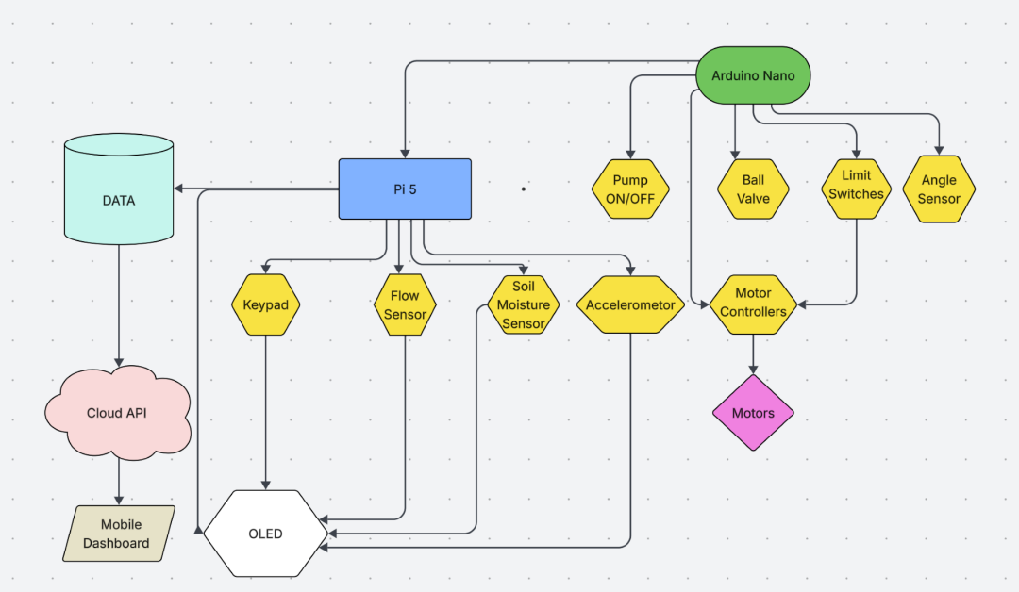
- Figure 2 – Wiring Diagram 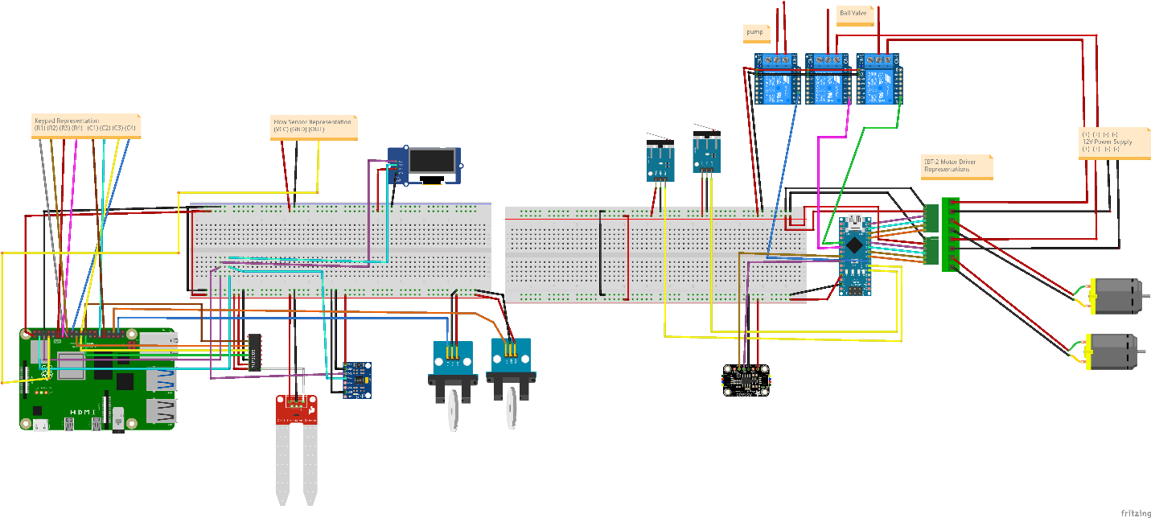

- Figure 3 – CAD model for tower concept
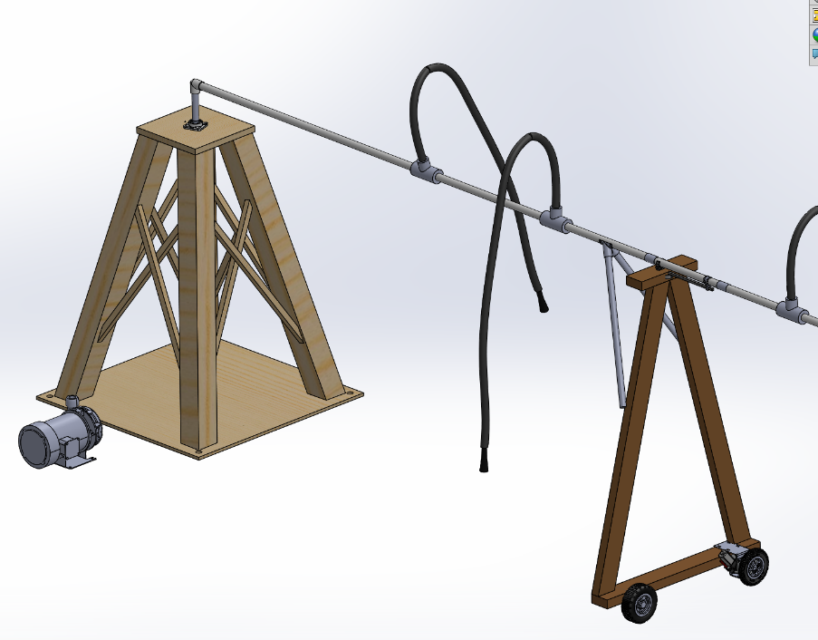
- Figure 4 – Completed Prototype 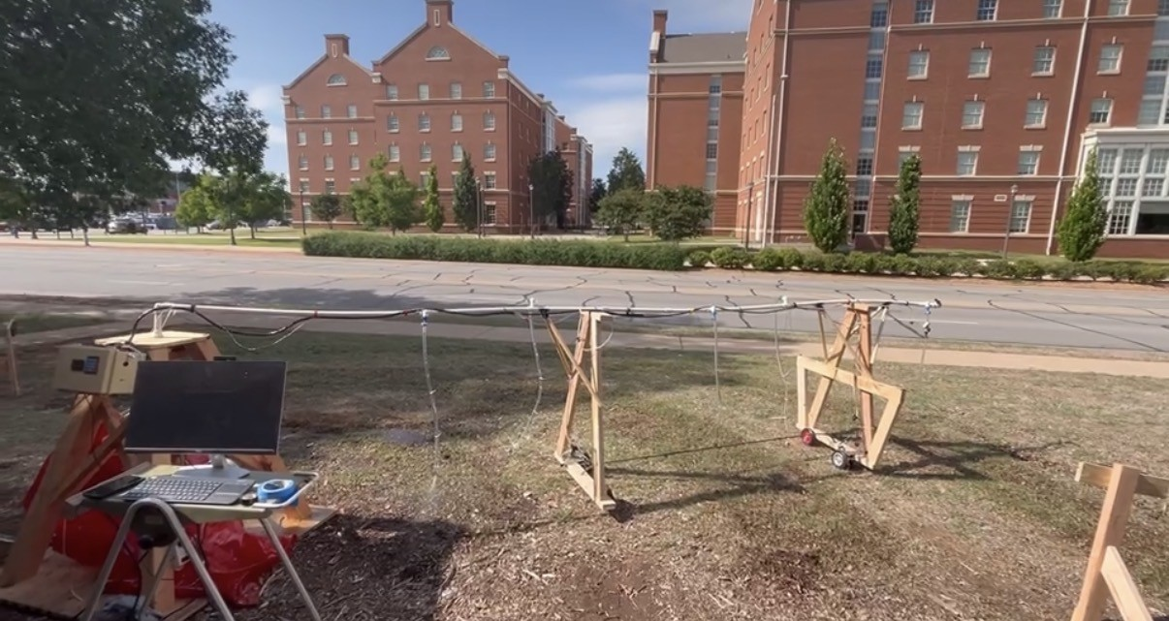

- Figure 5 – OLED
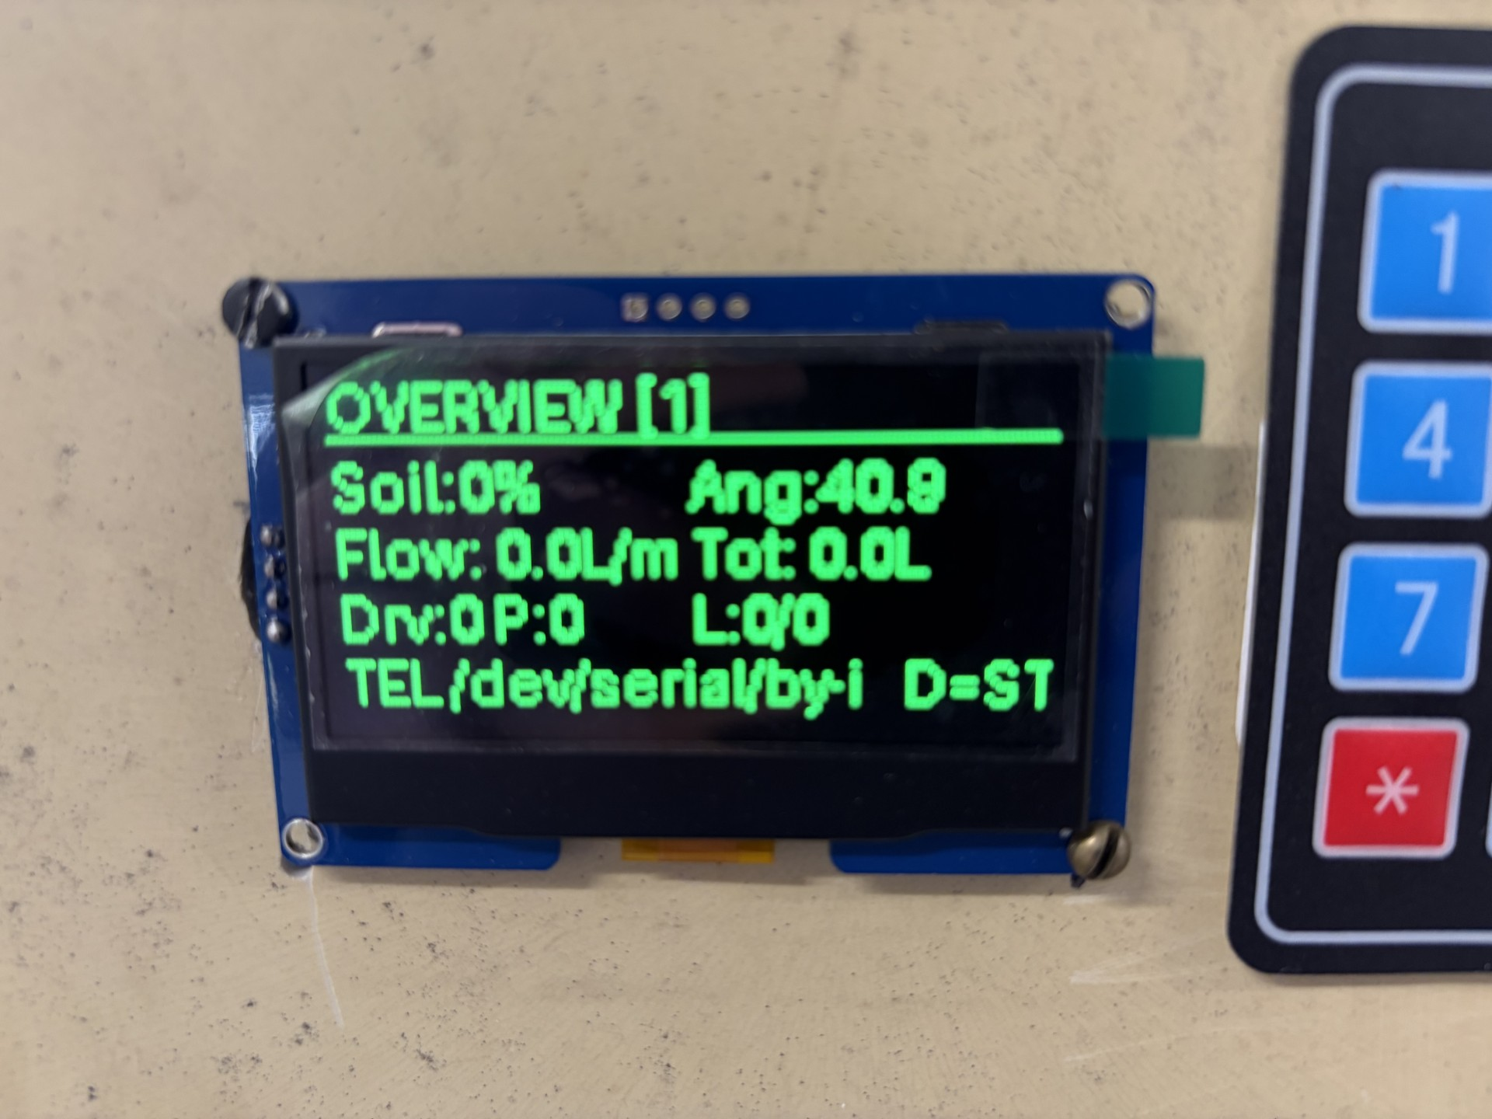
- Figure 6 – Mobile Dashboard
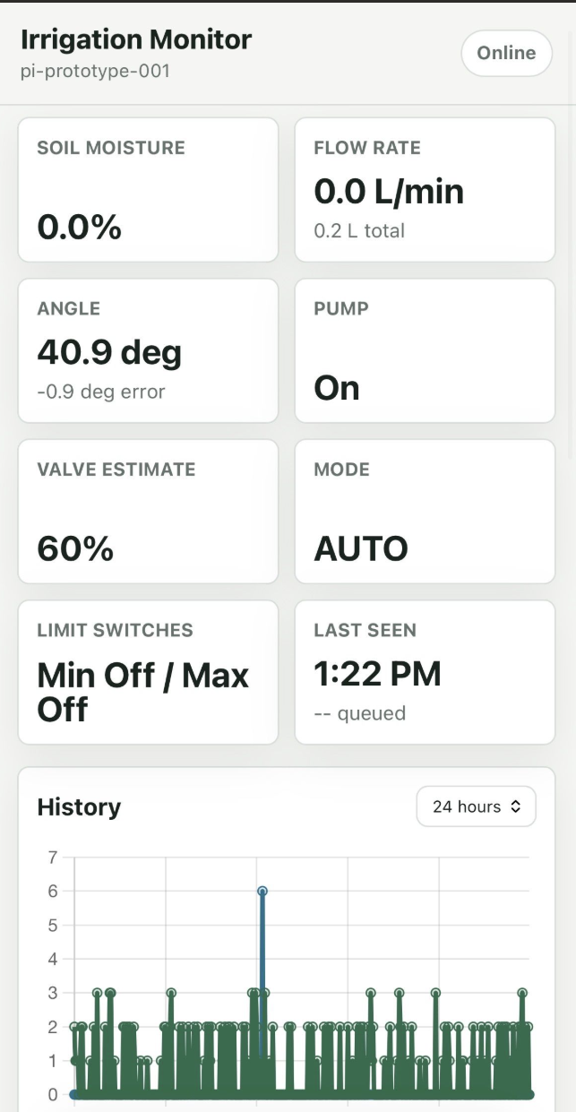

- Figure 7 – Control Box Assembly
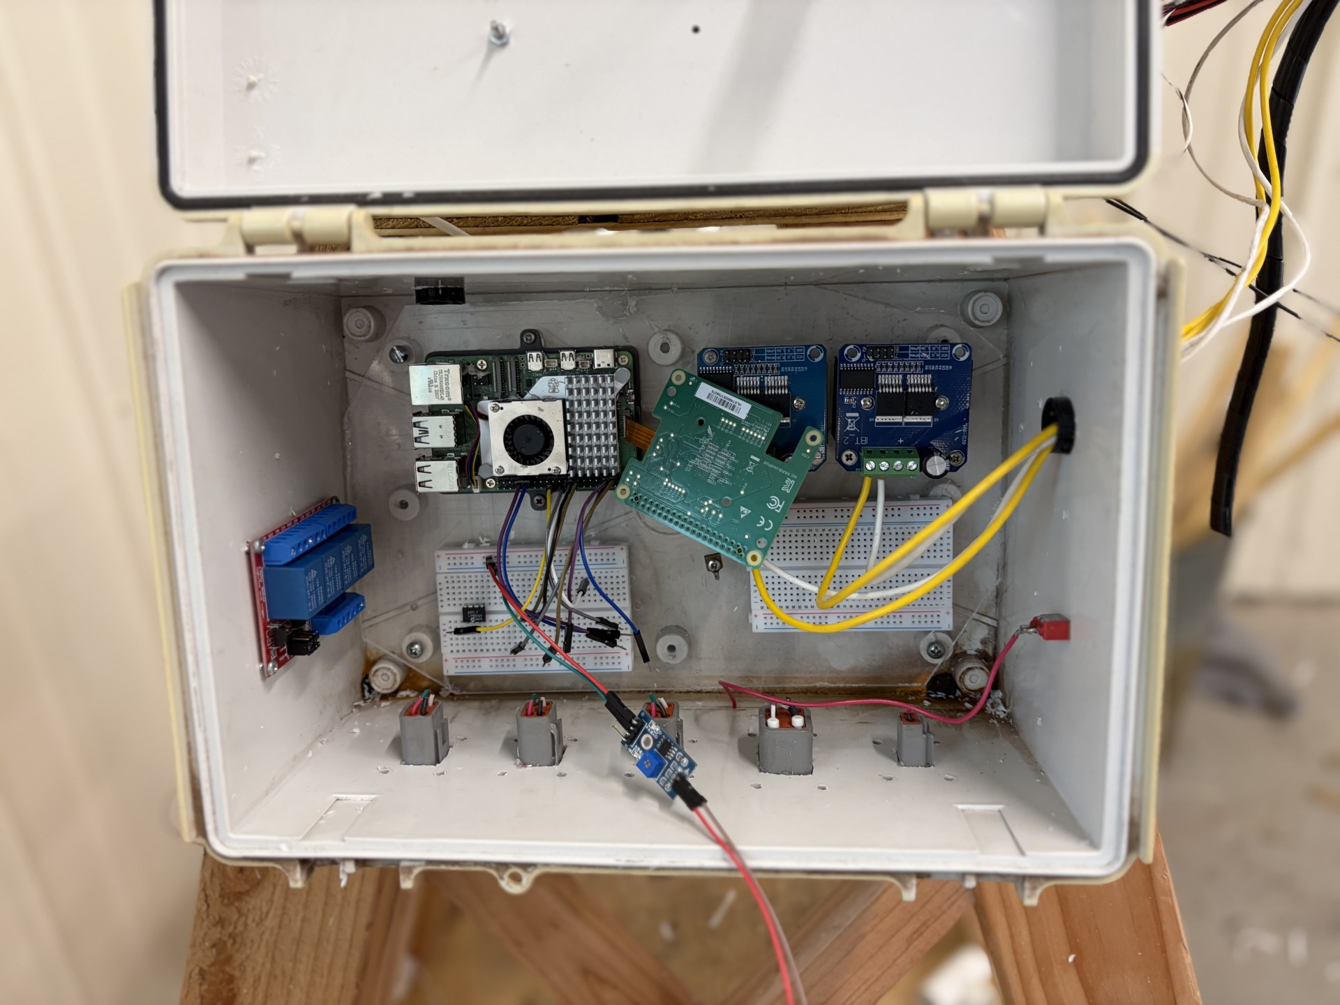
Figure 8 – Logic Flowchart
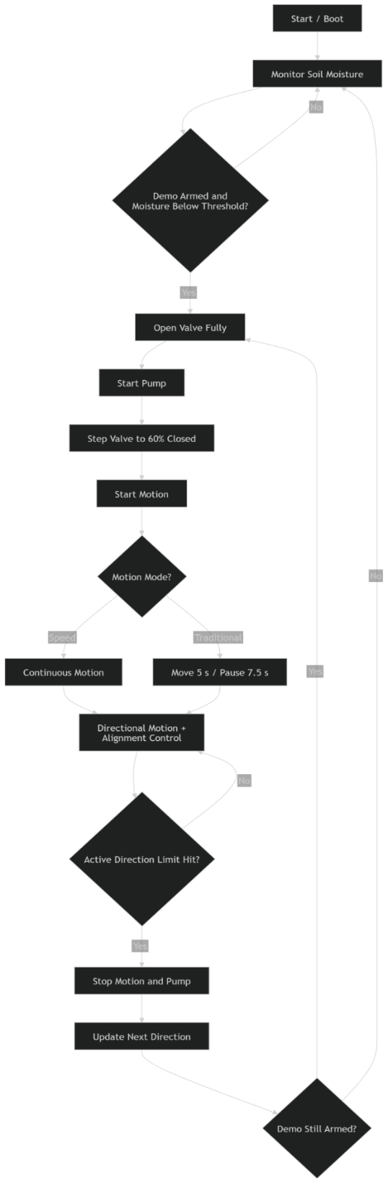

- Structural Design
The physical prototype represents a simplified center pivot irrigation system. The structure includes a fixed pivot support, a pipe span, sprinkler drop lines, and two mobile tower assemblies. The prototype uses a ¾ inch pipe span with multiple nozzles to distribute water. The presentation identifies the structure as approximately 16 ft long with two mobile towers about 4.5 ft tall, 12V motors, custom mounting brackets, 3D-printed mounts, and a 1 HP pump.
The 3D model was used to plan the mechanical layout before construction. The model shows the central pivot support, mobile tower frames, drive wheel assemblies, pipe span, and sprinkler drops. This layout allows the system to demonstrate both water delivery and motion control while remaining small enough for testing and presentation.

- Electronic Design
The electronic design connects the sensing, control, and actuation hardware through the Raspberry Pi 5 and Arduino Nano. The Raspberry Pi reads sensor inputs such as soil moisture, flow rate, and vibration/tilt, while also controlling the OLED display and keypad interface. The Python program uses GPIO callbacks for pulse-based flow measurement and reads accelerometer values to calculate vibration magnitude, vibration standard deviation, and tilt.
The Arduino Nano controls the pump relay, motorized ball valve relays, limit switches, AS5600 angle sensor, and motor drivers. The Nano code assigns PWM pins for two IBT-2 motor drivers, digital input pins for limit switches, relay outputs for valve open, valve close, and pump control, and I2C communication for the AS5600 angle sensor. The Nano also sends telemetry back to the Raspberry Pi, including motor commands, angle, limit switch states, pump state, valve estimate, drive state, direction, speed, target angle, alignment error, and demo state.
A relay-based design is used for the pump and ball valve because these devices require higher-current switching than the Raspberry Pi or Arduino GPIO pins can provide directly. Motor controllers are used to drive the 12V tower motors with directional and PWM speed control.
- Software Design
The software is separated into Raspberry Pi supervisory software and Arduino Nano local-control firmware.
The Raspberry Pi Python program manages the operator interface, data logging, sensor readings, and serial communication with the Arduino Nano. The OLED interface includes multiple pages for overview, soil moisture, flow, vibration, Nano status, water control, drive control, and demo mode. The keypad allows the operator to switch display pages, control the pump and valve, adjust drive speed, toggle direction, start or stop motion, arm demo mode, and issue an emergency stop command. The Python program also logs data to a CSV file with timestamped values for soil moisture, flow, vibration, tilt, Nano telemetry, motor commands, valve estimate, pump state, demo state, and motion mode.
The Arduino Nano firmware provides real-time control of the motor and water. It implements an automatic drive mode in which one motor provides forward motion, and the second motor corrects alignment using the AS5600 angle sensor. The firmware uses directional limit switch logic so one limit switch stops forward travel and the other stops reverse travel. It also includes water-control commands for pump on/off, valve open/close steps, force-open, and valve stop. In demo mode, the Nano opens the valve, starts the pump, throttles the valve to an estimated target position, drives the tower until a directional limit is reached, then stops the system and prepares for the next run.

- Testing and Evaluation Procedures
The system was evaluated using individual subsystem tests followed by full-system operation tests. Each sensor, actuator, and control function was tested independently before integration.
Test | Procedure | Expected Result
OLED/keypad interface | Press keypad buttons to change pages and issue commands | OLED updates correctly, and commands are recognized
Flow sensor test | Run water through the system and observe the flow rate | Flow rate and total volume update on the display/dashboard
Soil moisture trigger test | Change the soil moisture reading or threshold | Demo mode starts when moisture falls below the threshold
Pump relay test | Command pump on/off from the software | Pump turns on and off correctly
Ball valve relay test | Command open/close/force-open | Valve moves in the correct direction and stops after the timed command
Motor drive test | Command drive on/off and change speed | Motors respond to PWM speed command
Direction test | Toggle forward/reverse mode | Travel motor changes direction
Limit switch test | Trigger each limit switch | System stops or reverses according to directional logic
Alignment test | Move tower out of alignment | Alignment motor corrects based on angle error
Data logging test | Run system and inspect CSV/dashboard | Sensor and telemetry values are recorded with timestamps
Full demo test | Arm demo mode and trigger irrigation sequence | Valve opens, pump starts, valve throttles, drive begins, and system stops at limit

- Results and Discussion
The current prototype successfully demonstrated the major project functions, including local control of the pump, ball valve, and tower motion. The system also demonstrated sensor-based irrigation sequence triggering, directional limit switch behavior, automatic demo rearming, selectable motion modes, local OLED/keypad interaction, cloud logging, and cellphone dashboard display. These results align with the intended goal of integrating water control, motion control, and data acquisition into a single working irrigation demonstration platform.
The mobile dashboard displayed system values including soil moisture, flow rate, angle, pump state, valve estimate, operating mode, limit switch status, last-seen time, and recent history. This confirms that the system can communicate operational data beyond the local controller, supporting the long-term goal of remote monitoring.
The data logging system provides the foundation for future predictive maintenance work. Logged parameters such as motor commands, vibration, flow rate, valve position estimate, alignment angle, and limit switch events could eventually be used to identify abnormal operating patterns.

Test | Expected Result | Observed Result | Status
Pump relay activation | Pump turns on when commanded | Pump activated from controller | Passed
Ball valve close command | Valve moves toward closed position | Valve responded through relay control | Passed
Limit switch reached | Travel motor stops or reverses | Directional limit behavior worked | Passed
Alignment correction | Tower motor adjusts based on angle | System corrected misalignment | Passed
Cloud logging | Sensor data uploads to dashboard | Data visible on phone dashboard | Passed

- Team Collaboration
Example structure:
Team Member | Responsibilities
Alec Anderson | System design, controls logic, Raspberry Pi/Arduino integration, Mechanical design, report writing
Jack Pipkin | Mechanical structure, tower construction, pump and ball valve control wiring

- Engineering Conclusions
- The prototype successfully demonstrates a working center pivot irrigation platform.
- The system integrates water control, motion control, sensor inputs, local interface, and data logging.
- The Raspberry Pi/Arduino split was effective because the Pi handled user interaction and logging while the Arduino handled time-sensitive control.
- The system creates a foundation for future predictive maintenance work.

- Reflection and Recommendations
Reflecting over the process of this project, there area many changes that would have been good to implement throughout. These include better prototype testing before actual testing, better organization of data, and overall better scheduling throughout the process. These would have allowed the workflow to be smoother, as well as coordinate our progress. As far as tangible/technical challenges that we would recommend fixing would be:
- I2C/OLED freezing or bus issues
- Sensor reliability issues
- Pressure sensor failure/replacement
- Limit switch troubleshooting
- Motor current/noise affecting electronics
- Outdoor testing differences compared with indoor testing
- Alignment control sensitivity
- Power distribution and grounding challenges
Many of these challenges came towards the end of our project, once everything started to coincide, but they took up several hours of our time in troubleshooting.

- Bill of Materials
Item # | Qty | Part Name | Model # / Part # | Source / Vendor | Est. Unit Price | Est. Total
1 | 5 | 4x2x8 boards | Common 2x4x8 framing stud | Lowe's | $4.00 | $20.00
2 | 2 | 4x4x8 boards | Common 4x4x8 post | Lowe's | $13.00 | $26.00
3 | 3 | 6 ft dowel rods | Wood dowel rod, 6 ft | Lowe's | $8.00 | $24.00
4 | 30 | 1/2 in poly tubing | 1/2 in poly irrigation tubing | Lowe's | $0.50 | $15.00
5 | 5 | Spray nozzles | McMaster spray nozzle, exact part TBD | McMaster-Carr | $8.00 | $40.00
6 | 16 | Hose clamps | Stainless steel worm-drive hose clamp | Lowe's | $1.25 | $20.00
7 | 20 | 3/4 in PVC pipe | 3/4 in Schedule 40 PVC pipe | Lowe's | $0.60 | $12.00
8 | 2 | U-clamps | 3/4 in U-clamp or conduit strap | Lowe's | $2.50 | $5.00
9 | 4 | 3D printed connecting joints | Custom CAD/3D printed connector | In-house 3D print | $3.00 | $12.00
10 | 1 | 4 ft x 4 ft plywood panel | 1 in plywood panel 4x4 | Lowe's | $45.00 | $45.00
11 | 15 | 3/4 in poly tubing | 3/4 in poly irrigation tubing | Lowe's | $0.80 | $12.00
12 | 1 | 3/4 in PVC ball valve | 3/4 in Schedule 40 PVC ball valve | Lowe's | $8.00 | $8.00
13 | 6 | 3/4 in PVC tee joints | 3/4 in Schedule 40 PVC tee | Lowe's | $1.25 | $7.50
14 | 2 | Rubber tires | Rubber wheel/tire, diameter TBD | McMaster-Carr | $12.00 | $24.00
15 | 1 | Magnetic angle sensor | AS5600 magnetic angle sensor module or equivalent | Amazon | $8.00 | $8.00
16 | 2 | 12V motor/wheel components | 12V DC gear motor + wheel kit | Amazon | $25.00 | $50.00
17 | 1 | Flow sensor | YF-S201 or similar hall-effect flow sensor | Amazon | $10.00 | $10.00
18 | 2 | Limit switches | Micro limit switch with lever | Amazon | $2.00 | $4.00
19 | 1 | Electrical box | Plastic project box / electrical enclosure | Dr. Wang | $20.00 | $20.00
20 | 1 | 12V power source | 12V DC supply/battery, amperage TBD | Dr. Wang | $25.00 | $25.00
21 | 1 | Arduino Nano | Arduino Nano or Nano-compatible board | Dr. Wang | $12.00 | $12.00
22 | 1 | Raspberry Pi 5 | Raspberry Pi 5, RAM size TBD | Dr. Wang | $80.00 | $80.00
23 | 1 | 12V ball valve | 12V 3/4 in motorized ball valve, model TBD | Amazon | $35.00 | $35.00
24 | 1 | OLED display | 0.96 in I2C OLED, SSD1306 | Dr. Wang | $8.00 | $8.00
25 | 1 | 4x4 keypad | 4x4 matrix membrane keypad | Dr. Wang | $6.00 | $6.00
26 | 1 | 4-channel relay module | 5V 4-channel relay module | Dr. Wang | $8.00 | $8.00
27 | 2 | Motor drivers | L298N, TB6612FNG, or BTS7960 driver TBD | Dr. Wang | $15.00 | $30.00

- References
- Alciatore, D. G., & Histand, M. B. Introduction to Mechatronics and Measurement Systems 5th ed. McGraw-Hill Education.
- Wang, N. (2026). BAE3023 Instrumentation and Control Lectures. Oklahoma State University
- Raspberry Pi Foundation. Raspberry Pi Documentation: Raspberry Pi Computer Hardware.
- Pinout.xyz. Raspberry Pi GPIO Pinout
- Arduino. Arduino Nano Documentation
- United States Department of Agriculture, Natural Resources Conservation Service. (n.d.). Chapter 6: Irrigation system design. National Engineering Handbook, Part 652, National Irrigation Guide. https://irrigationtoolbox.com/NEH/Part652_NationalIrrigationGuide/ch6.pdf
- OpenAI. (2026). ChatGPT (GPT-5.5 Thinking) [Large language model]. https://chatgpt.com/

